**Web Services Final Project**

**DailyMap Final Documentation**

**Team: DailyMap**

**Team Member: M10609304張以慈 M10609106洪麒鈞**

**M10609109徐詩涵 M10609121詹哲宇**

**Project Goal**

In Taiwan, Taipei is a main city which attracts all kinds of person. From students, workers, creators to other people to reach their goal, chase after their dreams or to seek for the abundance of resource. Many of them aren’t familiar to the environment of Taipei, making it difficult to find a perfect place to settle down. For example, Taiwan often suffer from natural disaster, like typhoon which causes floods, earthquake which makes slopes shatters and soil liquefaction making building trembles.

Due to these problems, we present a simple web service which provides users to input an address or coordinates to check if the place they are in interest is safe to settle. It can help the user check if the place is in the zone which flood and soil liquefaction might occur, also to see if the place is built on the fault line. Furthermore, we also will add information to let the user see if the input address is near places which may often be crowed causing noise, or near to traffic hot spot, letting the noise disturb your daily routine.

**Web Service Introduction**

By giving the system the address or GPS coordinates, users will receive the neighborhood information of the spot they are searching to. The information that the system provides covers three aspects: point, line and plane. The following describes detail of these three aspects.

Points: In this section, the system displays the spots in the neighborhood which are public and matters to people’s living quality. Such as hospitals, schools, department stores, super markets, convenient stores, parks, post offices and so on.

Lines: Public transport always be the most-concern thing especially in the urban area. Therefore, the system shows the nearest public stations of high speed rail, railway, and metro and will also tell how far to reach to the searching spot. Also consider that how frequently earthquakes occur in Taiwan, the fault line will also be considered in this part.

Plane: Due to the global warming and overdeveloping, we think people should be more aware of the geographical features of the location they are willing to dwell in. Users could know whether the location is built in a soil liquefaction zone and a flood zone by simply inputting the accurate address or coordinates to the system.

**Web Service Layout:**

Front Page:

The user can type in their interested location in the search bar to get results. Also, they can click the “Search by map” button to find information by using the map. The input value can be address or coordinate.

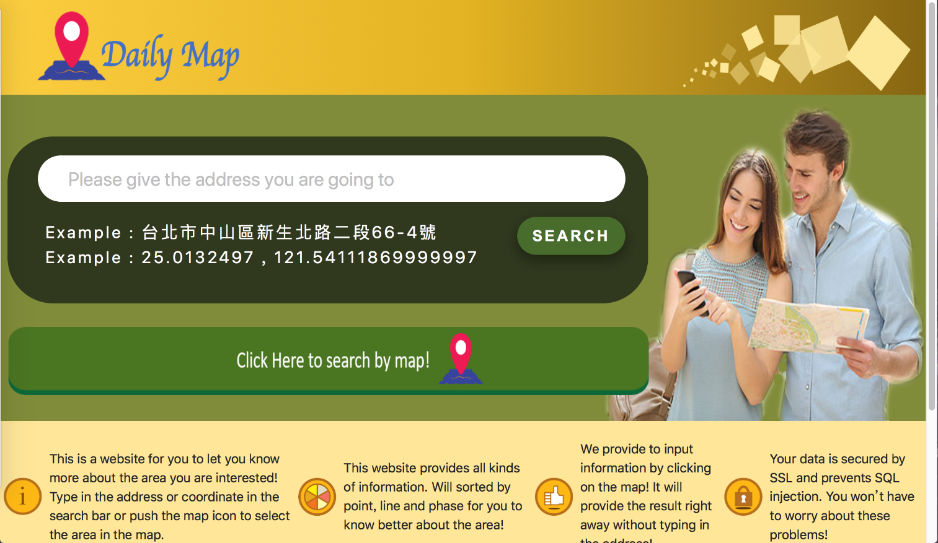

Fig 1. Front Page Layout

Search by search bar Page:

The user can get the information about the interested location. The detailed information will be show below the address bar.

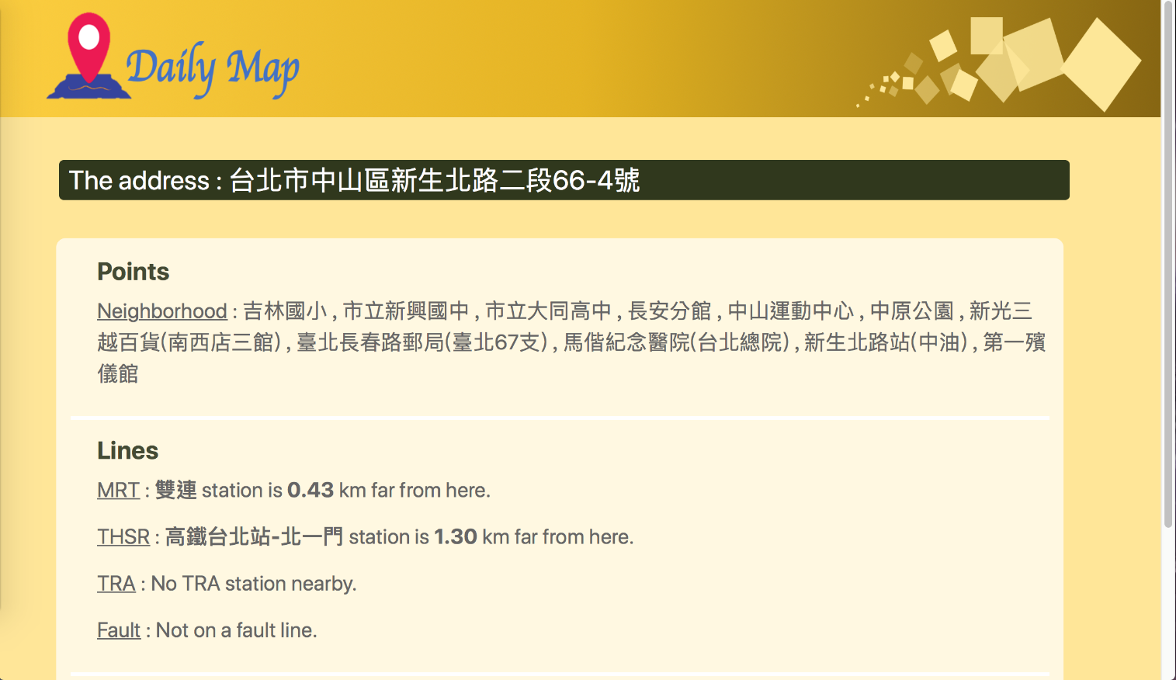

Fig 2. Search by Search Bar Page Layout

Search by map Page:

The user can get the information by clicking on the map or by typing the location in the search bar on the top-right corner. The results will be shown on the map and detailed on the right-side list. The input value of the search bar can be address or coordinate.

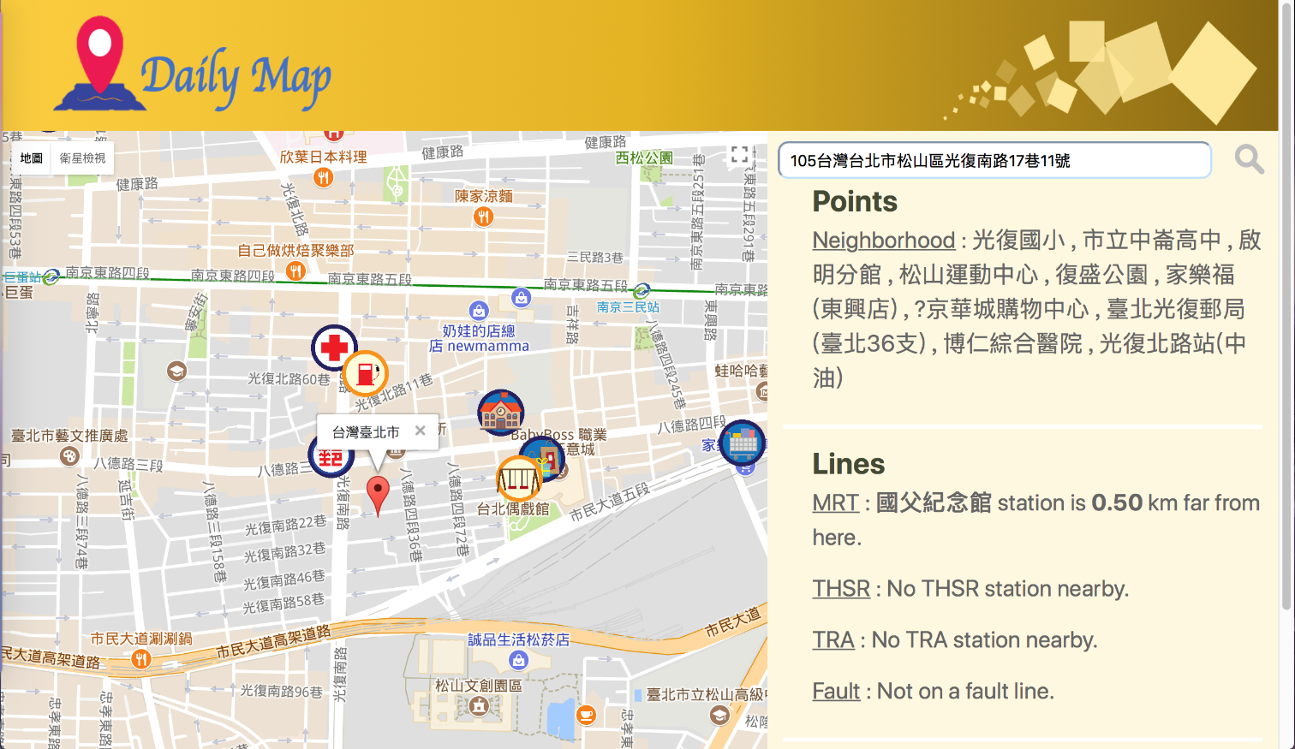

Fig 3. Search by Map Page Layout

**Project Implementation Plan**

1. Main Web Service: Provides user to input there coordinate or address. By gathering the nearby information about the input position, the system will show the assembled results and present to the user.

2. Point API: Find the target facilities in radius of two miles. The facilities will likely to be parks, hospitals or post offices and furthermore. It will also give the block distance between the input position and the target facilities.

3. Line API: Finds the transportation facilities in radius of two miles. The facilities will likely to be MRT, High-speed Railway stations and train stations. The API will also give the straight distance between input position and the target facilities.

4. Plane API: Finds whether the input position on a fault zone, on a soil liquefaction area or frequent flooded area.

5. Backup API’s: All of the API will also be supported by backup APIs, When the Main Web Service sends request to the Main APIs but doesn’t receive a response, the Main Web Service will send the request to the backup API. The backup API’s will not be built in the same computer, so if one of the API’s computer is out of service, the backup API’s computer can substitute the originals API’s work.

6. Database: Holds the different information of the map. Including detailed information about buildings and facilities, the transportation line ant stations, fault line, flood zone and the soil liquefaction zone.

Backup Point API

Point API

Database

Main Web Service

Backup Line API

Line API

Plane API

Backup Plane API

Fig 4. Structure Flow of the web service

**Proposed Security**

As for security mechanisms, we have planned to secure our system by the following three mechanisms:

* Https: Building a safe channel on the Internet by encrypting packets and creating certificate allows us to prevent from sniffing and attacking by the middle man.
* SQL Injection: This happens in the database of the application. For example, user input is embedded in SQL statements and incorrectly filtered for string and unexpectedly implemented. By doing this, attackers may be able to attack any type of SQL database.

In our website, what can users do are inputting address or GPS coordinates. For the former one, the system will pass the address to Google and then Google will return us the coordinates of that address. The coordinates will be transferred into numbers so that attackers will obtain an error if they trying to modify or transmit SQL string. The operation and result is similar when a user adopts the later method.

**performance evaluation mechanisms**

We adopted the following two software to evaluate the performance of our system:

* Google PageSpeed Insights: This is provided by Google for measuring the performance of a page for mobile and desktop devices. PageSpeed ​​Insights measures website performance based on two metrics: Load time without scrolling: The time elapsed since the user requested a new webpage until the browser renders the content without scrolling. The time to load the full page: Time elapsed since the user requested a new webpage until the browser rendered the full webpage content. It also proposes solutions that help to improve the performance of the web page.

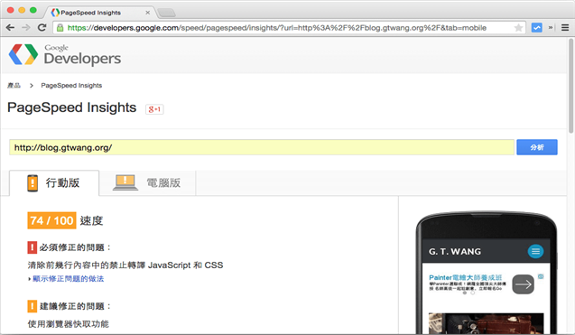

Fig 5. PageSpeed Insight User Interface

* Pingdom Website Speed Test: The company provides website speed test to assist users find out where to improve the performance of the website. The tool lets the page be tested from multiple locations, see how fast a website loads in Europe, the United States, etc. The tool thoroughly inspects sites and displays loading time in charts which clearly show the specific elements that delay the loading time. The tool also offers performance scores and improvement suggestions to help users optimizing websites.

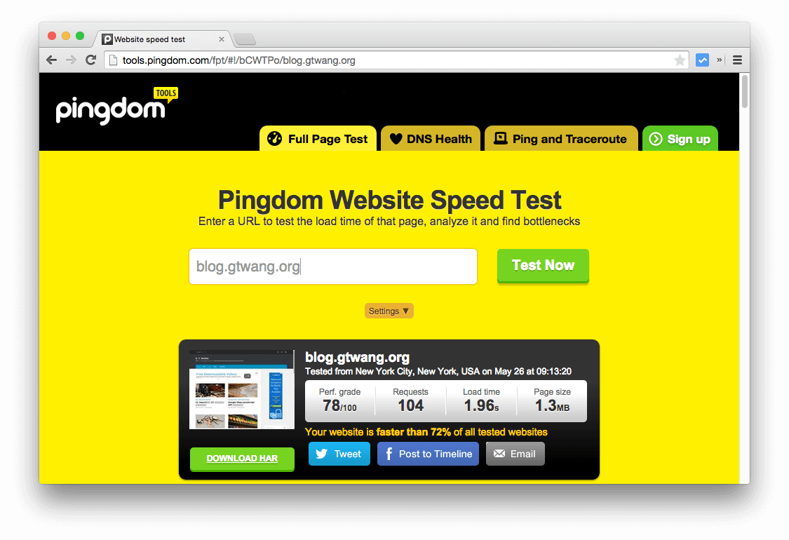s

Fig 6. Pingdom Website Speed Test user Interface

The web service’s performance evaluation is shown below

Google PageSpeed Insights:

Front Page Performance Evaluation: **85/100 (Good)**

Search by Search Bar Page Performance Evaluation: **87/100(Good)**

Search by Map Page Performance Evaluation: **86/100(Good)**

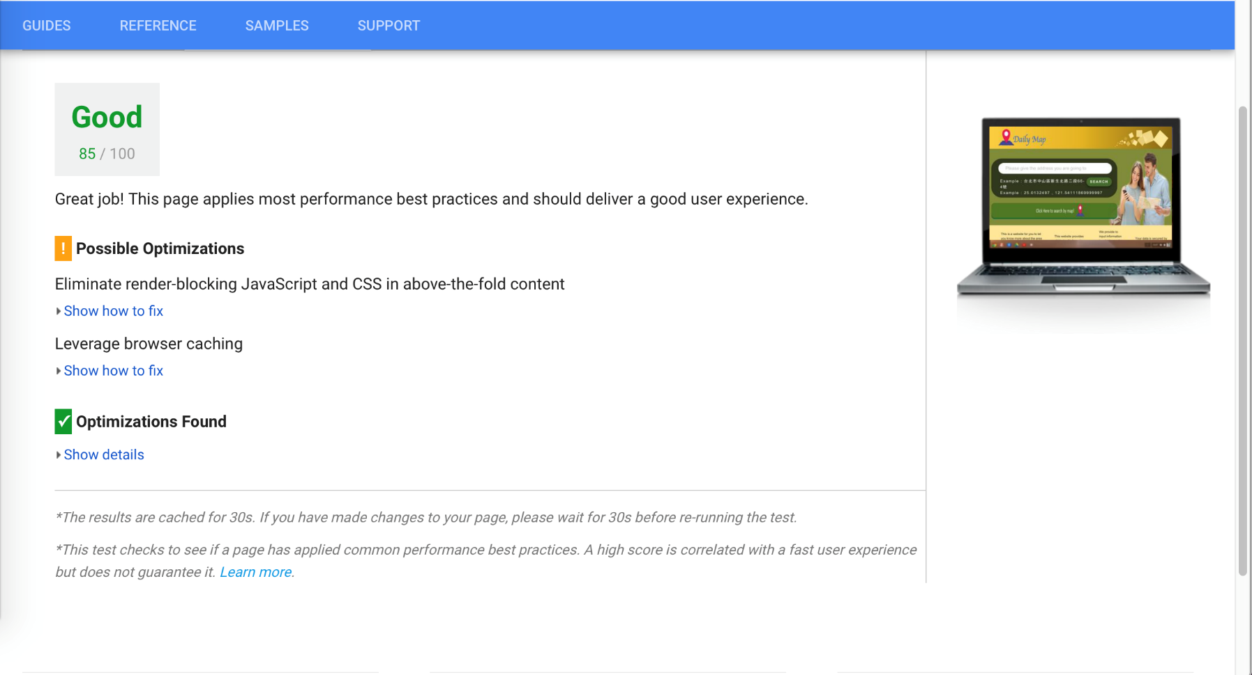

Fig 7. Front Page Performance Evaluation by Google PageSpeed Insight

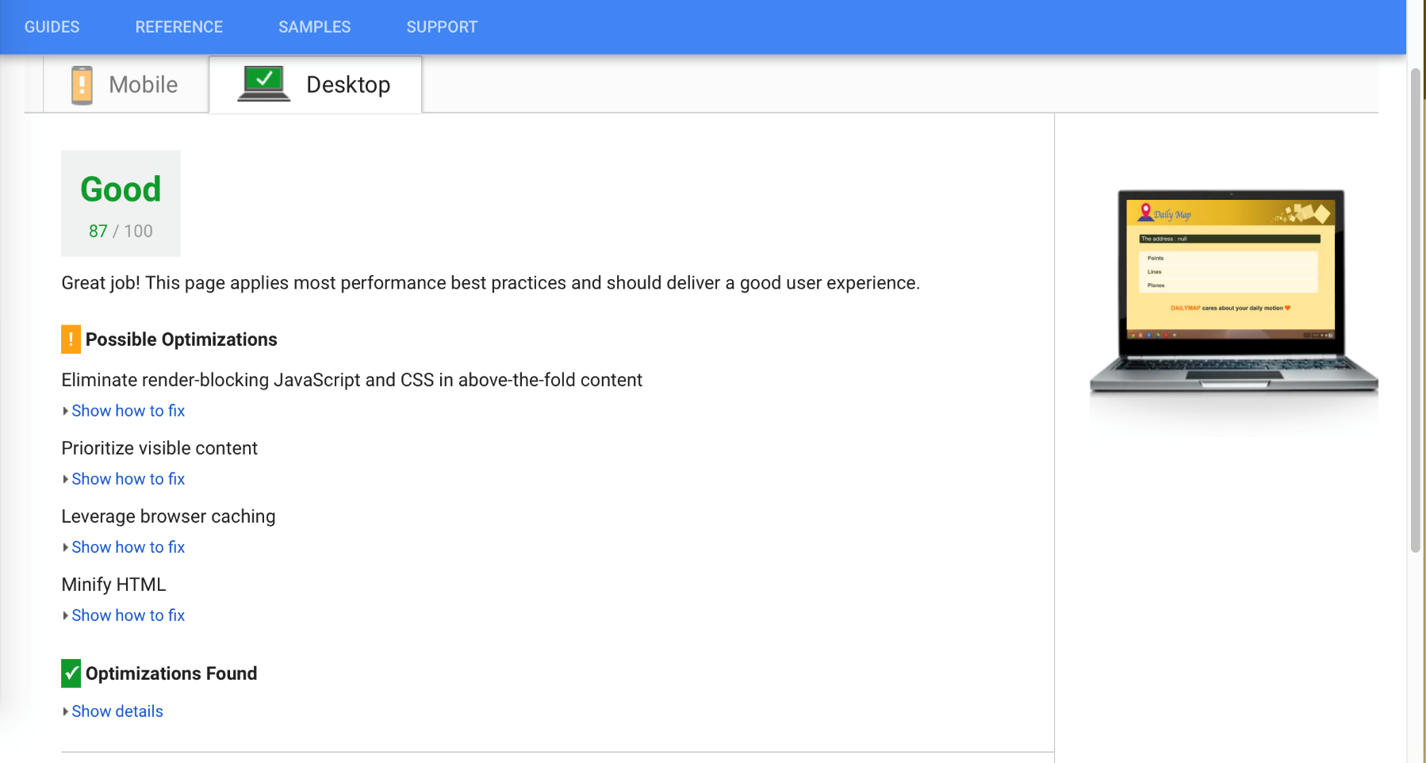

Fig 8. Search by Search Bar Page Performance Evaluation by Google PageSpeed Insight

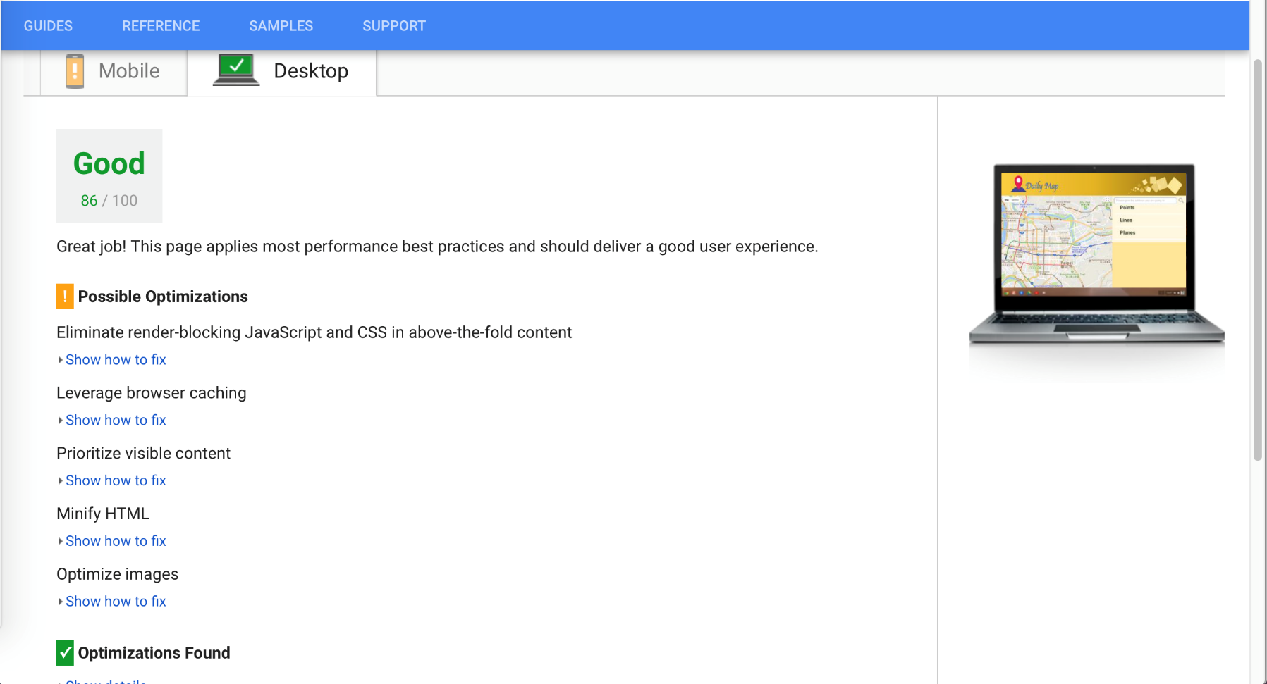

Fig 9. Search by Map Page Performance Evaluation by Google PageSpeed Insight

Pingdom Website Speed Test:

Front Page Performance Evaluation: **85/100 (Rank B)**

Search by Search Bar Page Performance Evaluation: **89/100 (Rank B)**

Search by Map Page Performance Evaluation: **87/100 (Rank B)**

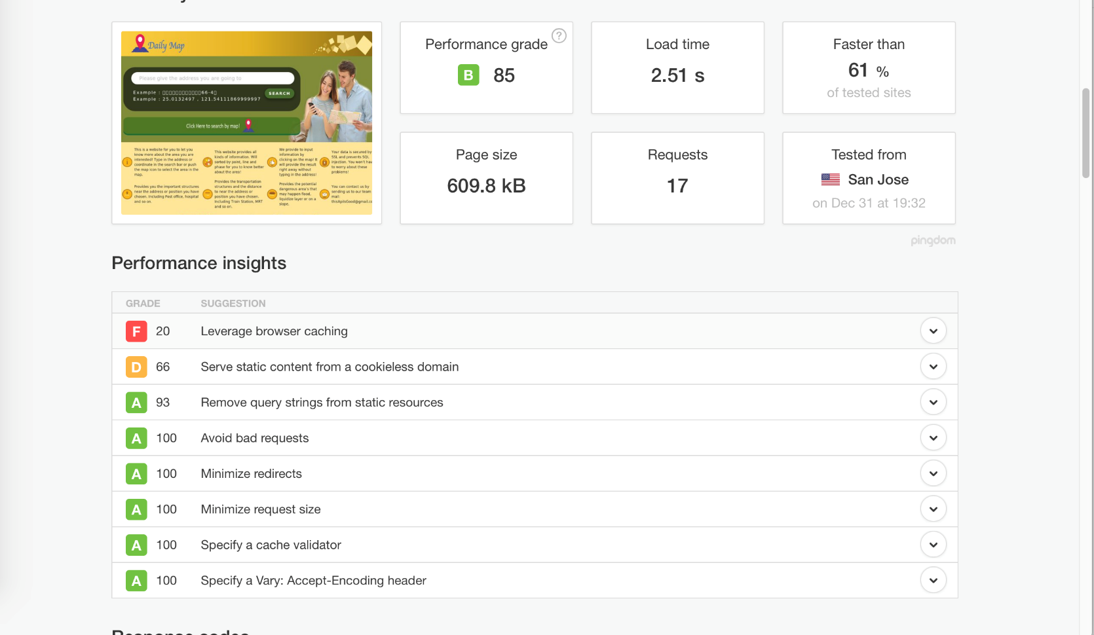

Fig 10. Front Performance Evaluation by Pingdom

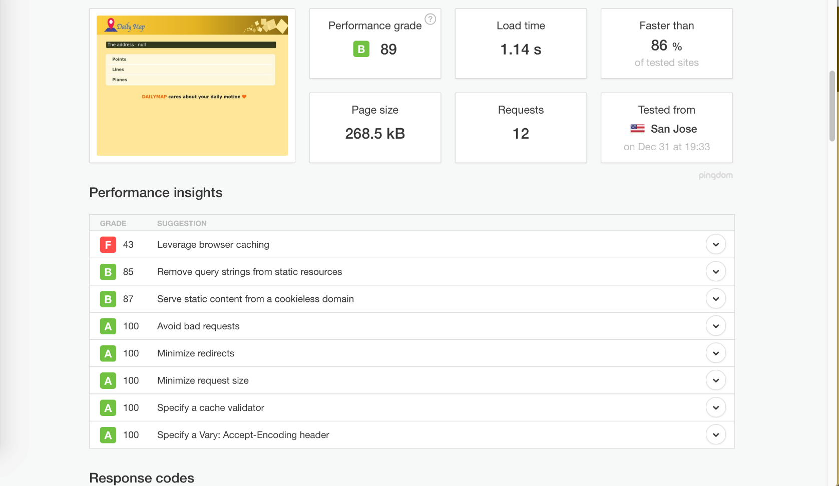

Fig 11. Search by Search Bar Page Performance Evaluation by Pingdom

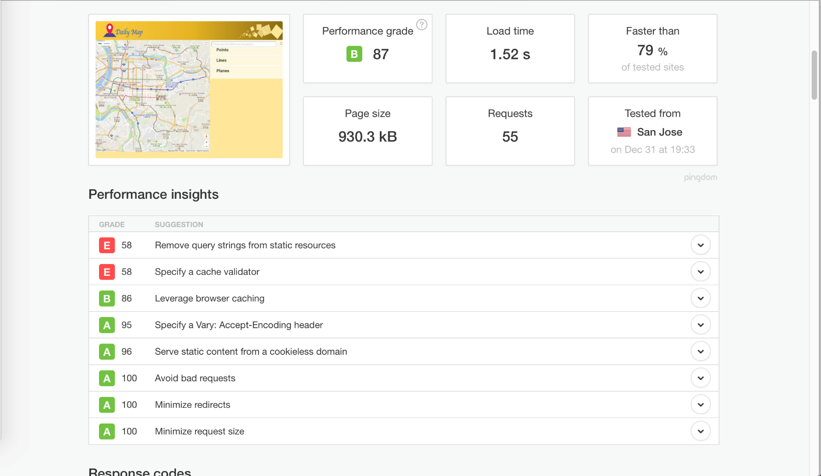

Fig 11. Search by Map Page Performance Evaluation by Pingdom

By the web speed testing websites, we can see some issues that can promote the speed of our website. By using these websites, we can now how some problems can be solved to leverage the speed.

**Future Work**

There are several issues that we consider should be done in the future. They are listed below:

1. Search through the whole country instead of Taipei. Since the web service we provide only serves for Taipei only, we think that to stretch the area to the entire country is an important part for us. But if the area gets bigger, the requesting time will also be difficult to deal with. After dealing with the problems, the web service hopefully can serve the whole nation.

2. Give options for users to customize their need. While we can show all the information we have to the user, some user only needs to search for specific surrounding information. Or might only need to search not by address but how the information distributes on the map.

3. Connect with renting websites to locate and find easier. For some people, they use the website to compare with renting websites to see if the place they are ready to dwell at is safe enough. If we can connect with renting websites, users can easily find safer houses instead of comparing by switching pages.

4. Leverage the user experience. There are some places that may not be that convenient to use. These will be adjusted in the future.

**Conclusion**

By the structure and introduction above, we aim to give the users more information to choose a place much safer. Though the population in Taipei is dense, it doesn’t mean that every place people dwell on is secured. This is why we want to let people know more about the information they live at. By showing the flood zone, fault zone, soil liquefaction area and the information about transportation hot spots, we can likely leverage the quality where the user’s will dwell at.

**References**

<https://zh.wikipedia.org/wiki/SQL%E8%B3%87%E6%96%99%E9%9A%B1%E7%A2%BC%E6%94%BB%E6%93%8A>

<https://zh.wikipedia.org/wiki/%E8%B6%85%E6%96%87%E6%9C%AC%E4%BC%A0%E8%BE%93%E5%AE%89%E5%85%A8%E5%8D%8F%E8%AE%AE>

<https://free.com.tw/pingdom-tools/>

Google PageSpeed Insights: <https://developers.google.com/speed/pagespeed/insights/>

Pingdom Website Speed Test : <https://tools.pingdom.com/>